姓名：杲时雨
学号：2019116022
时间：2020.12.29
编号：2

Project: Bank Account Manager
（1）问题描述：
设计一个充当ATM机的程序。用户可以指定一个PIN，并向他们显示帐户类型（支票和储蓄）的菜单。允许用户从选定的帐户类型存款或取款。如果有超过1万美元的存款，他们肯定不会让银行经理告诉他们，如果有超过1万美元的存款，他们会让他们联系银行。这是类继承的一个经典示例。创建一个Account类，它将作为这两种类型帐户的基础。支票账户和储蓄账户都是对的吗？它们将从基本Account类继承。在基类中保留基本功能，如deposit（）和draw（），然后在特定帐户类型中重写它们。一个储蓄账户也可能会有利息或罚款的东西提取任何钱。重写这些方法时要考虑到这一点。变量“balance”也是基类的受保护成员。允许支票账户转为负数，并收取10美元的透支费。不要让用户进入透支保护超过100美元。如果用户已经透支，您还可以防止他们进行多次提款。

（2）设计：
UML类图：
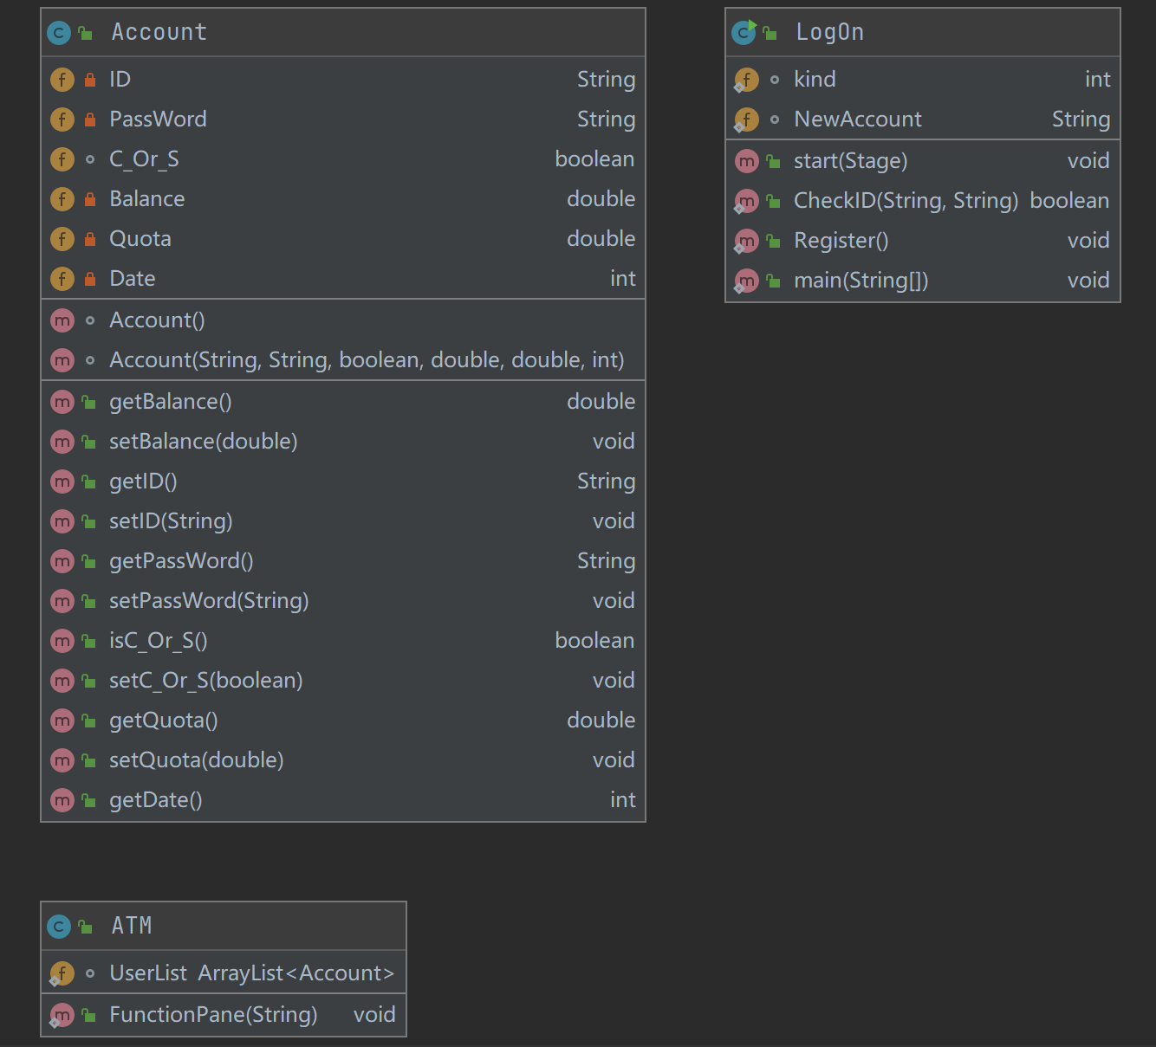
UI界面设计：
登录页面：
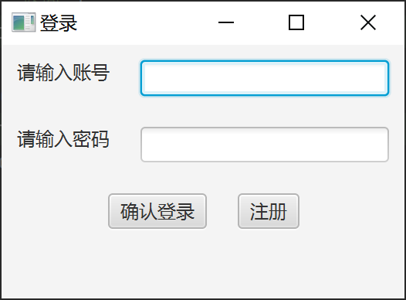

功能页面：
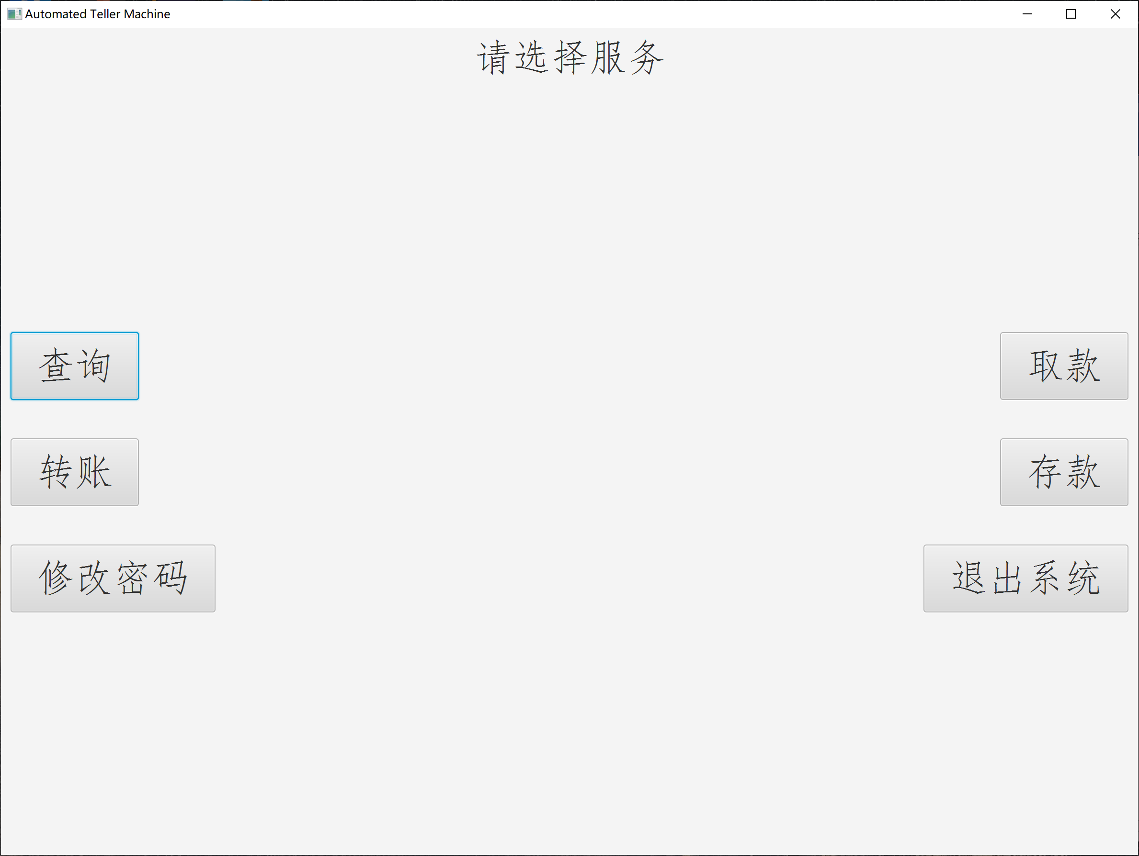

（3）代码：
LogOn类：
import java.io.File;
import java.util.Random;
import java.util.Scanner;
import java.io.FileWriter;
import java.util.Calendar;
import javafx.scene.Scene;
import javafx.stage.Stage;
import java.io.IOException;
import javafx.geometry.Pos;
import javafx.geometry.Insets;
import javafx.scene.layout.HBox;
import javafx.scene.layout.VBox;
import javafx.scene.control.Label;
import javafx.scene.control.Button;
import java.io.FileNotFoundException;
import javafx.application.Application;
import javafx.scene.control.TextField;
import javafx.scene.control.RadioButton;
import javafx.scene.control.ToggleGroup;

public class LogOn extends Application
{
static int kind=0;
static String NewAccount="";
// public static ArrayList<Account> UserList=new ArrayList<Account>();
//登录界面
@Override
public void start(Stage primaryStage)
{
Stage Log=new Stage();
VBox Body=new VBox();
Body.setSpacing(20);
Body.setPadding(new Insets(10,10,10,10));

//VB第一行是一个HB,账号
HBox ID=new HBox();
ID.setSpacing(20);
Label id=new Label("请输入账号");
TextField GetID=new TextField();
ID.getChildren().addAll(id,GetID);
//VB第二行是一个HB,密码
HBox PassWord=new HBox();
PassWord.setSpacing(20);
Label code=new Label("请输入密码");
TextField GetCode=new TextField();
PassWord.getChildren().addAll(code,GetCode);
//第三行是一个HB,两个按钮:确认登录和什么呢
HBox Buttons=new HBox();
Buttons.setSpacing(20);
Buttons.setAlignment(Pos.CENTER);
Button confirm=new Button("确认登录");
Button register=new Button("注册");
Buttons.getChildren().addAll(confirm,register);
Label warming=new Label("");

Body.getChildren().addAll(ID,PassWord,Buttons,warming);
Scene scene=new Scene(Body);
Log.setScene(scene);
Log.setTitle("登录");

confirm.setOnAction
(
e->
{
String account=GetID.getText();
String password=GetCode.getText();
if( CheckID(account,password) )
{
System.out.println("Successfully");

ATM.FunctionPane(account);
Log.close();
}
else
warming.setText("账号或密码有误");
}
);
register.setOnAction
(
e->
{
Log.close();
Register();
}
);
Log.show();
}
//检查账号密码是否正确
public static boolean CheckID(String ID,String Code)
{
File file=new File("D:\\Java Study(NWU)\\src\\Final_Assignment_For_Java\\ATM\\UserList.txt");
try
{
Scanner read=new Scanner(file);
while(read.hasNext())
{
String target=read.nextLine();
String []part=target.split("-");
if(ID.equals(part[0])&&Code.equals(part[1]))
{
read.close();
return true;
}

else
continue;
}
read.close();
return false;
}
catch(FileNotFoundException e)
{
System.out.println("源文件受损");
}
return false;
}
//注册账号
public static void Register()
{
Stage stage=new Stage();
VBox VB=new VBox();
VB.setSpacing(20);
VB.setAlignment(Pos.CENTER_LEFT);
VB.setPadding(new Insets(20,20,20,20));

Random random=new Random();
for(int i=0;i<10;i++)
{
NewAccount+=random.nextInt(10);
if(i==0&&NewAccount.equals("0"))
{
i=-1;
NewAccount="";
}
}

Label YourAccount=new Label("您的账号为: "+NewAccount);
HBox HB=new HBox();
HB.setSpacing(20);
HB.setAlignment(Pos.CENTER_LEFT);
Label CodeSign=new Label("请设置您的密码: ");
TextField GetCode=new TextField();
HB.getChildren().addAll(CodeSign,GetCode);
HBox ChoiceKind=new HBox();
ChoiceKind.setAlignment(Pos.CENTER_LEFT);
ChoiceKind.setSpacing(15);
Label tip=new Label("是否创建支票账户: ");
RadioButton Checking=new RadioButton("支票账户");
ChoiceKind.getChildren().addAll(tip,Checking);
ToggleGroup CCS=new ToggleGroup();
Checking.setToggleGroup(CCS);
Checking.setOnAction
(
e->
{
if( Checking.isSelected() )
kind=1;
else
kind=0;
}
);
HBox BUTTON=new HBox();
Button Finished=new Button("确认创建");
BUTTON.setAlignment(Pos.CENTER);
BUTTON.getChildren().add(Finished);

Finished.setOnAction
(
e->
{
String Code=GetCode.getText();
boolean K=(kind==1);
String AccountNumber=NewAccount;

File NewFileArray=new File("D:\\Java Study(NWU)\\src\\Final_Assignment_For_Java\\ATM\\UserList.txt");
if( !NewFileArray.exists() )
{
try
{
NewFileArray.createNewFile();
System.out.println( NewFileArray.mkdir() );
}
catch(IOException er)
{
System.out.println("创建文件失败");
}
}

NewFileArray=new File("D:\\Java Study(NWU)\\src\\Final_Assignment_For_Java\\ATM\\UserList.txt");
try
{
int Date=Calendar.getInstance().get(Calendar.YEAR);
FileWriter Record=new FileWriter(NewFileArray,true);
Record.write(AccountNumber+"-"+Code+"-"+K+"-"+0+"-"+100*(K?1:0)+"-"+Date+"\n");
Record.flush();
Record.close();
}
catch (IOException er)
{
System.out.println("记录数据失败");
}
stage.close();
}
);

VB.getChildren().addAll(YourAccount,HB,ChoiceKind,BUTTON);
Scene scene=new Scene(VB);
stage.setScene(scene);
stage.setTitle("注册账号");
stage.show();
}
public static void main(String[] args)
{
Application.launch(args);
}
}

ATM类：
import java.io.File;
import java.util.Scanner;
import java.util.Calendar;
import java.io.FileWriter;
import javafx.scene.Scene;
import javafx.stage.Stage;
import java.util.ArrayList;
import javafx.geometry.Pos;
import java.io.IOException;
import javafx.geometry.Insets;
import javafx.scene.layout.HBox;
import javafx.scene.layout.VBox;
import javafx.scene.control.Label;
import javafx.scene.control.Button;
import java.io.FileNotFoundException;
import javafx.scene.layout.BorderPane;
import javafx.scene.control.TextField;

public class ATM
{
static ArrayList<Account> UserList=new ArrayList<Account>();
public static void FunctionPane (String TargetAccount)
{
//在一切开始之前，把文件里的数据读出成为ArrayList
File DataFile=new File("D:\\Java Study(NWU)\\src\\Final_Assignment_For_Java\\ATM\\UserList.txt");
try
{
Scanner First=new Scanner(DataFile);
while(First.hasNext())
{
String user=First.nextLine();
String[] Parts=user.split("-");
boolean kind=Parts[2].equals("true")?true:false;
double balance=Double.parseDouble(Parts[3]);
double quota=Double.parseDouble(Parts[4]);
int date=Integer.parseInt(Parts[5]);
Account NewUser=new Account(Parts[0],Parts[1],kind,balance,quota,date);
UserList.add(NewUser);
}
for(int k=0;k<UserList.size();k++)
{
System.out.println(UserList.get(k).getID()+" "+UserList.get(k).getBalance());
}
First.close();
}
catch (FileNotFoundException e2)
{
System.out.println("源文件受损");
}

Stage primaryStage=new Stage();
BorderPane Pane=new BorderPane();
VBox Left=new VBox();
Left.setSpacing(40);
Left.setAlignment(Pos.CENTER_LEFT);
Left.setPadding(new Insets(10,10,10,10));
VBox Right=new VBox();
Right.setSpacing(40);
Right.setAlignment(Pos.CENTER_RIGHT);
Right.setPadding(new Insets(10,10,10,10));
HBox Title=new HBox();
Title.setPadding(new Insets(10,10,10,10));
Title.setAlignment(Pos.CENTER);
Label sign=new Label("请选择服务");
sign.setStyle("-fx-font-family: 'FangSong';-fx-font-size: 40;");
Title.getChildren().add(sign);

Button Query=new Button("查询");
Query.setStyle("-fx-font-family: 'FangSong';-fx-font-size: 40;");
Button Giro=new Button("转账");
Giro.setStyle("-fx-font-family: 'FangSong';-fx-font-size: 40;");
Button ChangeCode=new Button("修改密码");
ChangeCode.setStyle("-fx-font-family: 'FangSong';-fx-font-size: 40;");
Button Withdraw=new Button("取款");
Withdraw.setStyle("-fx-font-family: 'FangSong';-fx-font-size: 40;");
Button Deposit=new Button("存款");
Deposit.setStyle("-fx-font-family: 'FangSong';-fx-font-size: 40;");
Button Exit=new Button("退出系统");
Exit.setStyle("-fx-font-family: 'FangSong';-fx-font-size: 40;");

//下面是给按钮设置事件部分
//查询按钮
Query.setOnAction
(
e->
{
primaryStage.close();
Stage Q_Stage=new Stage();
Q_Stage.setWidth(1200);
Q_Stage.setHeight(900);
BorderPane Q_Pane=new BorderPane();

VBox L=new VBox();
L.setPadding(new Insets(10,10,10,10));
L.setAlignment(Pos.CENTER);
VBox R=new VBox();
R.setPadding(new Insets(10,10,10,10));
R.setAlignment(Pos.CENTER);
Button exit=new Button("返回");
exit.setStyle("-fx-font-family: 'FangSong';-fx-font-size: 40;");
L.getChildren().add(exit);
Button Q_Balance=new Button("查询余额");
Q_Balance.setStyle("-fx-font-family: 'FangSong';-fx-font-size: 40;");
R.getChildren().add(Q_Balance);
exit.setOnAction
(
ee->
{
Q_Stage.close();
ATM.FunctionPane(TargetAccount);
}
);
Q_Balance.setOnAction
(
eq->
{
Stage ShowBalance=new Stage();
ShowBalance.setWidth(400);
ShowBalance.setHeight(200);
Label balance=new Label();

File file=new File("D:\\Java Study(NWU)\\src\\Final_Assignment_For_Java\\ATM\\UserList.txt");
try
{
Scanner read=new Scanner(file);
while(read.hasNext())
{
String stack=read.nextLine();
String []parts=stack.split("-");
if(parts[0].equals(TargetAccount))
balance.setText("您的余额为: "+parts[3]);
else
continue;
}
read.close();
}
catch (FileNotFoundException e1)
{
balance.setText("源文件受损");
}
HBox B=new HBox();
B.setPadding(new Insets(10,10,10,10));
B.setAlignment(Pos.CENTER);
balance.setStyle("-fx-font-family: 'FangSong';-fx-font-size: 40;");
B.getChildren().add(balance);
Scene s=new Scene(B);
ShowBalance.setScene(s);
ShowBalance.setTitle("余额");

ShowBalance.show();
}
);

Q_Pane.setLeft(L);
Q_Pane.setRight(R);
Scene s=new Scene(Q_Pane);
Q_Stage.setScene(s);
Q_Stage.setTitle("查询");
Q_Stage.show();
}
);
//转账按钮
Giro.setOnAction
(
e->
{
primaryStage.close();
Stage Q_Stage=new Stage();
Q_Stage.setWidth(1200);
Q_Stage.setHeight(900);
BorderPane Q_Pane=new BorderPane();

VBox L=new VBox();
L.setPadding(new Insets(10,10,10,10));
L.setAlignment(Pos.CENTER);
VBox R=new VBox();
R.setPadding(new Insets(10,10,10,10));
R.setAlignment(Pos.CENTER);
Button exit=new Button("返回");
exit.setStyle("-fx-font-family: 'FangSong';-fx-font-size: 40;");
L.getChildren().add(exit);
Button QiroBalance=new Button("转账");
QiroBalance.setStyle("-fx-font-family: 'FangSong';-fx-font-size: 40;");
R.getChildren().add(QiroBalance);
exit.setOnAction
(
ee->
{
Q_Stage.close();
ATM.FunctionPane(TargetAccount);
}
);
QiroBalance.setOnAction
(
eq->
{
Stage Q_B_Stage=new Stage();
VBox V=new VBox();

//第一行是一个HB，用于得到目标账户
HBox GetTarget=new HBox();
GetTarget.setPadding(new Insets(10,10,10,10));
GetTarget.setAlignment(Pos.CENTER);
Label Tip_T=new Label("请输入目标账户: ");
TextField TA_Number=new TextField();
GetTarget.getChildren().addAll(Tip_T,TA_Number);
//第二行是一个HB，用于得到转账数额
HBox GetNumber=new HBox();
GetNumber.setPadding(new Insets(10,10,10,10));
GetNumber.setAlignment(Pos.CENTER);
Label Tip_N=new Label("请输入转账数额: ");
TextField G_Number=new TextField();
GetNumber.getChildren().addAll(Tip_N,G_Number);
//第三行是什么都可以，确认按钮
HBox Action=new HBox();
Action.setPadding(new Insets(10,10,10,10));
Action.setAlignment(Pos.CENTER);
Button Yes=new Button("确认转账");
Action.getChildren().addAll(Yes);
//第四行是label，用于提示转账成功或者失败
HBox TIP=new HBox();
Label tip=new Label();
TIP.setPadding(new Insets(10,10,10,10));
TIP.setAlignment(Pos.CENTER);

V.getChildren().addAll(GetTarget,GetNumber,TIP,Action);
Q_B_Stage.setWidth(400);
Q_B_Stage.setHeight(220);
Scene s=new Scene(V);
Q_B_Stage.setScene(s);
Q_B_Stage.setTitle("转账");
Q_B_Stage.show();

Yes.setOnAction//确认转账
(
ey->
{
for(int i=0;i<UserList.size();i++)
{
if( UserList.get(i).getID().equals(TargetAccount) )//找到出账账户
{
double T=Double.parseDouble( G_Number.getText() );
double B=UserList.get(i).getBalance();
boolean CS=UserList.get(i).isC_Or_S();
double Q=UserList.get(i).getQuota();
if( B>T )
{
UserList.get(i).setBalance(B-T);
tip.setText("转账成功");
for(int j=0;j<UserList.size();j++)
{
if( UserList.get(j).getID().equals( TA_Number.getText() ) )
//找到入账账户
{
double TB=UserList.get(j).getBalance();
boolean TCS=UserList.get(j).isC_Or_S();
double TQ=UserList.get(j).getQuota();
if(TCS)
{
if(TQ==100)
{
UserList.get(j).setBalance(TB+T);
}
else if(TQ+T>=100)
{
UserList.get(j).setQuota(100);
UserList.get(j).setBalance( Math.max(0,T+TQ-100)+TB );
}
else
{
UserList.get(j).setQuota(TQ+T);
}
}
else
{
UserList.get(j).setBalance(TB+T);
}
}
}
}
else if(CS)
{
if(B+Q>T+10)
{
UserList.get(i).setBalance(B-T-10);
UserList.get(i).setQuota(Q-T+B);
tip.setText("转账成功");
for(int j=0;j<UserList.size();j++)
{
if( UserList.get(j).getID().equals( TA_Number.getText() ) )
//找到入账账户
{
double TB=UserList.get(j).getBalance();
boolean TCS=UserList.get(j).isC_Or_S();
double TQ=UserList.get(j).getQuota();
if(TCS)
{
if(TQ==100)
{
UserList.get(j).setBalance(TB+T);
}
else if(TQ+T>=100)
{
UserList.get(j).setQuota(100);
UserList.get(j).setBalance(T+TQ-100+TB);
}
else
{
UserList.get(j).setQuota(TQ+T);
}
}
else
{
UserList.get(j).setBalance(TB+T);
}
}
}
}
}
else
{
tip.setText("转账失败，余额不足");
}
}
}
//重写
String data="";
for(int i=0;i<UserList.size();i++)
{
String line=UserList.get(i).getID()+"-"+
UserList.get(i).getPassWord()+"-"+
UserList.get(i).isC_Or_S()+"-"+
UserList.get(i).getBalance()+"-"+
UserList.get(i).getQuota()+"\n";
data+=line;
}
try
{
FileWriter ReWriter=new FileWriter(DataFile);
ReWriter.write(data);
System.out.println("正在重写入数据");
ReWriter.flush();
ReWriter.close();
}
catch (IOException e1)
{
System.out.println("源文件受损");
}
}
);
}
);

Q_Pane.setLeft(L);
Q_Pane.setRight(R);
Scene s=new Scene(Q_Pane);
Q_Stage.setScene(s);
Q_Stage.setTitle("查询");
Q_Stage.show();
}
);
//改密按钮
ChangeCode.setOnAction
(
e->
{
Stage change=new Stage();
VBox body=new VBox();

//第一行得到原密码
HBox one=new HBox();
one.setPadding(new Insets(10,10,10,10));
one.setAlignment(Pos.CENTER);
one.setSpacing(20);
Label tip1=new Label("请输入原密码");
TextField get1=new TextField();
one.getChildren().addAll(tip1,get1);
//第二行得到新密码
HBox two=new HBox();
two.setPadding(new Insets(10,10,10,10));
two.setAlignment(Pos.CENTER);
two.setSpacing(20);
Label tip2=new Label("请输入新密码");
TextField get2=new TextField();
two.getChildren().addAll(tip2,get2);
//第三行提示修改成功或失败
HBox three=new HBox();
three.setPadding(new Insets(10,10,10,10));
three.setAlignment(Pos.CENTER);
Label tip3=new Label("");
three.getChildren().addAll(tip3);
//第四行按钮
HBox four=new HBox();
four.setPadding(new Insets(10,10,10,10));
four.setAlignment(Pos.CENTER);
Button yes=new Button("确认修改");
four.getChildren().addAll(yes);

yes.setOnAction
(
ey->
{
for(int i=0;i<UserList.size();i++)
{
if(UserList.get(i).getID().equals(TargetAccount))
{
if(UserList.get(i).getPassWord().equals(get1.getText()))
{
UserList.get(i).setPassWord(get2.getText());
tip3.setText("修改成功");
}
else
{
tip3.setText("修改失败");
}
}
}
String data="";
for(int i=0;i<UserList.size();i++)
{
String line=UserList.get(i).getID()+"-"+
UserList.get(i).getPassWord()+"-"+
UserList.get(i).isC_Or_S()+"-"+
UserList.get(i).getBalance()+"-"+
UserList.get(i).getQuota()+"\n";
data+=line;
}
try
{
FileWriter ReWriter=new FileWriter(DataFile);
ReWriter.write(data);
System.out.println("正在重写入数据");
ReWriter.flush();
ReWriter.close();
}
catch (IOException e1)
{
System.out.println("源文件受损");
}
}
);

body.getChildren().addAll(one,two,three,four);
change.setWidth(400);
change.setHeight(240);
Scene s=new Scene(body);
change.setScene(s);
change.setTitle("修改密码");
change.show();
}
);
//取款按钮
Withdraw.setOnAction
(
e->
{
Stage draw=new Stage();
VBox body=new VBox();
body.setPadding(new Insets(10,10,10,10));
body.setAlignment(Pos.CENTER);
//第一行取款数额
HBox one=new HBox();
one.setPadding(new Insets(10,10,10,10));
one.setSpacing(20);
one.setAlignment(Pos.CENTER);
Label tip1=new Label("请输入存款数额:");
TextField get1=new TextField();
one.getChildren().addAll(tip1,get1);
//第二行提示成功或失败
HBox two=new HBox();
two.setAlignment(Pos.CENTER);
two.setPadding(new Insets(10,10,10,10));
Label tip2=new Label();
two.getChildren().add(tip2);
//第三行按钮
HBox three=new HBox();
three.setAlignment(Pos.CENTER);
three.setPadding(new Insets(10,10,10,10));
Button yes=new Button("确认存款");
three.getChildren().add(yes);

body.getChildren().addAll(one,two,three);
Scene s=new Scene(body);
draw.setWidth(400);
draw.setHeight(300);
draw.setScene(s);
draw.setTitle("存款");
draw.show();

yes.setOnAction
(
ey->
{
for(int i=0;i<UserList.size();i++)
{
if(UserList.get(i).getID().equals(TargetAccount))//找到客户
{
if(UserList.get(i).getBalance()>=10000)//重要客户
{
tip2.setText("您存款超过10000$,取款服务请联系经理\n联系电话:17394113071");
}
else
{
double T=Double.parseDouble(get1.getText());
double B=UserList.get(i).getBalance();
boolean CS=UserList.get(i).isC_Or_S();
double Q=UserList.get(i).getQuota();
if(B>=T)
{
UserList.get(i).setBalance(B-T);
tip2.setText("取款成功");
}
else if(CS)
{
if(B+Q-10>=T)
{
UserList.get(i).setBalance(B-10-T);
UserList.get(i).setQuota(Q+B-T);
tip2.setText("取款成功");
}
else
{
tip2.setText("余额不足,取款失败");
}
}
else
{
tip2.setText("余额不足,取款失败");
}
}
}
}
//重写
String data="";
for(int i=0;i<UserList.size();i++)
{
String line=UserList.get(i).getID()+"-"+
UserList.get(i).getPassWord()+"-"+
UserList.get(i).isC_Or_S()+"-"+
UserList.get(i).getBalance()+"-"+
UserList.get(i).getQuota()+"\n";
data+=line;
}
try
{
FileWriter ReWriter=new FileWriter(DataFile);
ReWriter.write(data);
System.out.println("正在重写入数据");
ReWriter.flush();
ReWriter.close();
}
catch (IOException e1)
{
System.out.println("源文件受损");
}
}
);
}
);
//存款按钮
Deposit.setOnAction
(
e->
{

Stage draw=new Stage();
VBox body=new VBox();
body.setPadding(new Insets(10,10,10,10));
body.setAlignment(Pos.CENTER);
//第一行取款数额
HBox one=new HBox();
one.setPadding(new Insets(10,10,10,10));
one.setSpacing(20);
one.setAlignment(Pos.CENTER);
Label tip1=new Label("请输入取款数额:");
TextField get1=new TextField();
one.getChildren().addAll(tip1,get1);
//第二行提示成功或失败
HBox two=new HBox();
two.setAlignment(Pos.CENTER);
two.setPadding(new Insets(10,10,10,10));
Label tip2=new Label();
two.getChildren().add(tip2);
//第三行按钮
HBox three=new HBox();
three.setAlignment(Pos.CENTER);
three.setPadding(new Insets(10,10,10,10));
Button yes=new Button("确认取款");
three.getChildren().add(yes);

body.getChildren().addAll(one,two,three);
Scene s=new Scene(body);
draw.setWidth(400);
draw.setHeight(300);
draw.setScene(s);
draw.setTitle("取款");
draw.show();

yes.setOnAction
(
ey->
{
for(int i=0;i<UserList.size();i++)
{
if(UserList.get(i).getID().equals(TargetAccount))//找到客户
{
double T=Double.parseDouble(get1.getText());
double B=UserList.get(i).getBalance();
boolean CS=UserList.get(i).isC_Or_S();
double Q=UserList.get(i).getQuota();
if(CS)
{
if(Q<100)
{
if(Q+T<=100)
{
UserList.get(i).setQuota(Q+T);
tip2.setText("存款成功");
}
else
{
UserList.get(i).setQuota(100);
UserList.get(i).setBalance(B+Q+T-100);
tip2.setText("存款成功");
}
}
else
{
UserList.get(i).setBalance(B+T);
tip2.setText("存款成功");
}
}
else
{
UserList.get(i).setBalance(B+T);
tip2.setText("存款成功");
}
}
}
//重写
String data="";
for(int i=0;i<UserList.size();i++)
{
String line=UserList.get(i).getID()+"-"+
UserList.get(i).getPassWord()+"-"+
UserList.get(i).isC_Or_S()+"-"+
UserList.get(i).getBalance()+"-"+
UserList.get(i).getQuota()+"\n";
data+=line;
}
try
{
FileWriter ReWriter=new FileWriter(DataFile);
ReWriter.write(data);
System.out.println("正在重写入数据");
ReWriter.flush();
ReWriter.close();
}
catch (IOException e1)
{
System.out.println("源文件受损");
}
}
);

}
);
//退出系统
Exit.setOnAction
(
e->
{
String data="";
for(int i=0;i<UserList.size();i++)
{
String line=UserList.get(i).getID()+"-"+
UserList.get(i).getPassWord()+"-"+
UserList.get(i).isC_Or_S()+"-"+
UserList.get(i).getBalance()+"-"+
UserList.get(i).getQuota()+"\n";
data+=line;
}
try
{
FileWriter ReWriter=new FileWriter(DataFile);
ReWriter.write(data);
System.out.println("正在保存数据");
ReWriter.flush();
ReWriter.close();
}
catch (IOException e1)
{
System.out.println("源文件受损");
}
primaryStage.close();
}
);
//检查利息
for(int i=0;i<UserList.size();i++)
{
int n=Calendar.getInstance().get(Calendar.YEAR)-UserList.get(i).getDate();
if(n>0)
{
UserList.get(i).setBalance(UserList.get(i).getBalance()*Math.pow(n,1.05));
}
}
String data="";
for(int i=0;i<UserList.size();i++)
{
String line=UserList.get(i).getID()+"-"+
UserList.get(i).getPassWord()+"-"+
UserList.get(i).isC_Or_S()+"-"+
UserList.get(i).getBalance()+"-"+
UserList.get(i).getQuota()+"\n";
data+=line;
}
try
{
FileWriter ReWriter=new FileWriter(DataFile);
ReWriter.write(data);
System.out.println("正在保存数据");
ReWriter.flush();
ReWriter.close();
}
catch (IOException e1)
{
System.out.println("源文件受损");
}
primaryStage.close();

Left.getChildren().addAll(Query,Giro,ChangeCode);
Right.getChildren().addAll(Withdraw,Deposit,Exit);
Pane.setTop(Title);
Pane.setLeft(Left);
Pane.setRight(Right);
Scene scene=new Scene(Pane);
primaryStage.setScene(scene);
primaryStage.setTitle("Automated Teller Machine");
primaryStage.setWidth(1200);
primaryStage.setHeight(900);
primaryStage.show();
}
}

Account类：
public class Account
{

private String ID="";
private String PassWord="";
boolean C_Or_S=false;//true代表checking,支票类型
private double Balance=0;
private double Quota=0.0;
private int Date;
Account()
{}
Account(String A_Number,String P_Number,boolean COS,double Balance,double Quota,int Date)
{
this.ID=A_Number;
this.PassWord=P_Number;
this.C_Or_S=COS;
this.Balance=Balance;
this.Quota=Quota;
this.Date=Date;
}
public double getBalance()
{
return Balance;
}
public void setBalance(double balance)
{
Balance = balance;
}
public String getID()
{
return ID;
}
public void setID(String iD)
{
ID = iD;
}
public String getPassWord()
{
return PassWord;
}
public void setPassWord(String passWord)
{
PassWord = passWord;
}
public boolean isC_Or_S()
{
return C_Or_S;
}
public void setC_Or_S(boolean c_Or_S)
{
C_Or_S = c_Or_S;
}
public double getQuota()
{
return Quota;
}
public void setQuota(double quota)
{
Quota = quota;
}
public int getDate()
{
return Date;
}
}
（4）运行程序的屏幕截图：
① 登陆页面，输入账号和密码，若无账号和密码可进行注册操作。
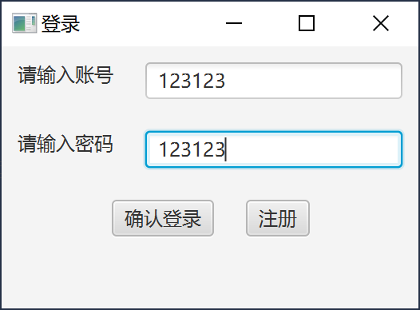

② 登录成功，进行服务选择。
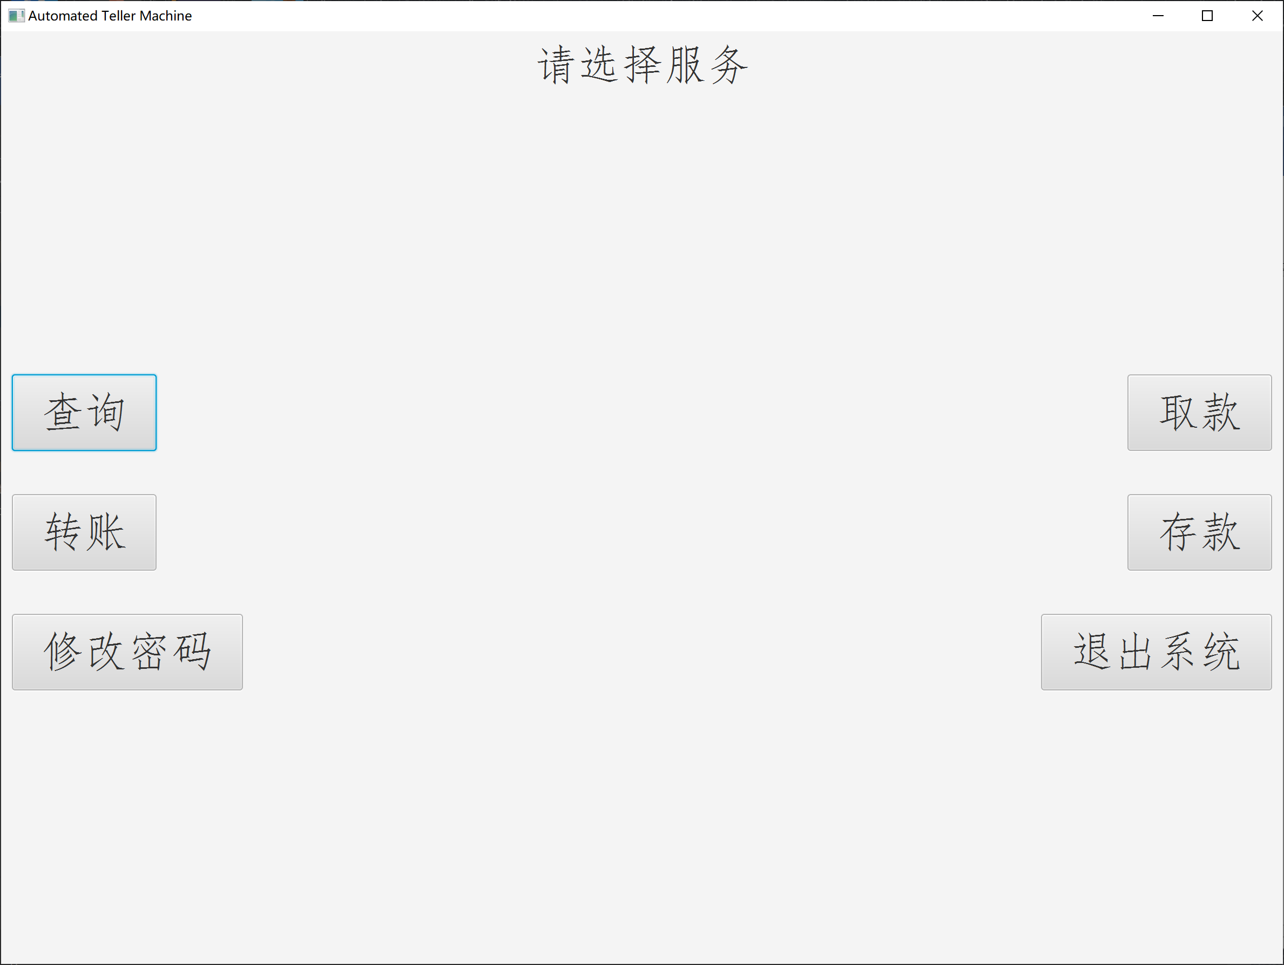
③ 进入查询页面
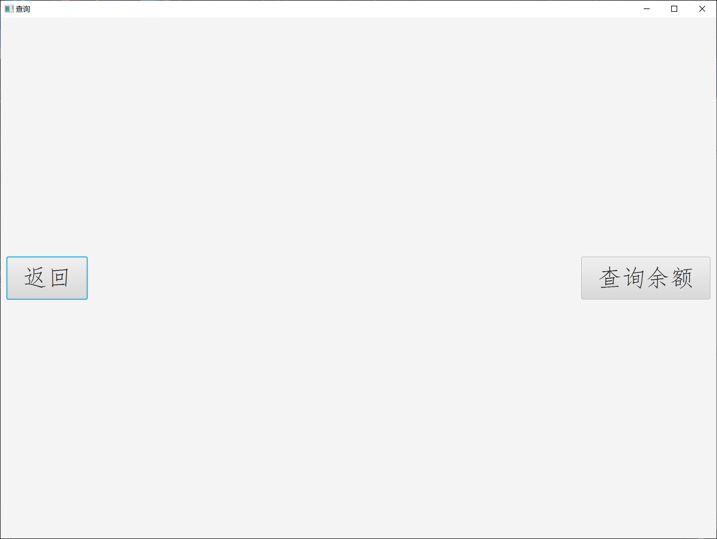

④ 点击查询余额
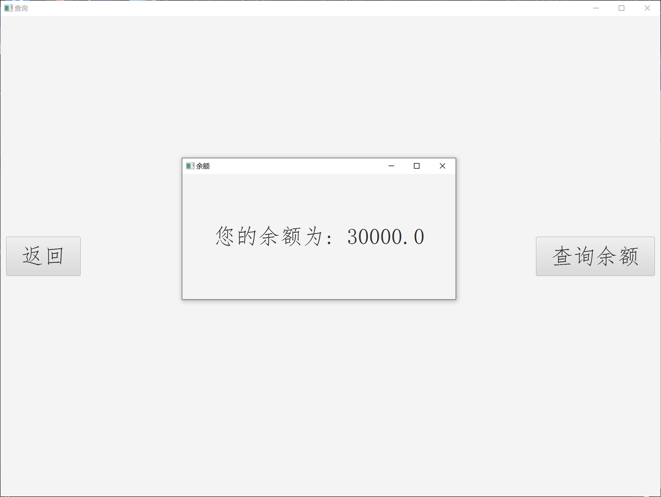

⑤ 点击存款，进行存钱业务
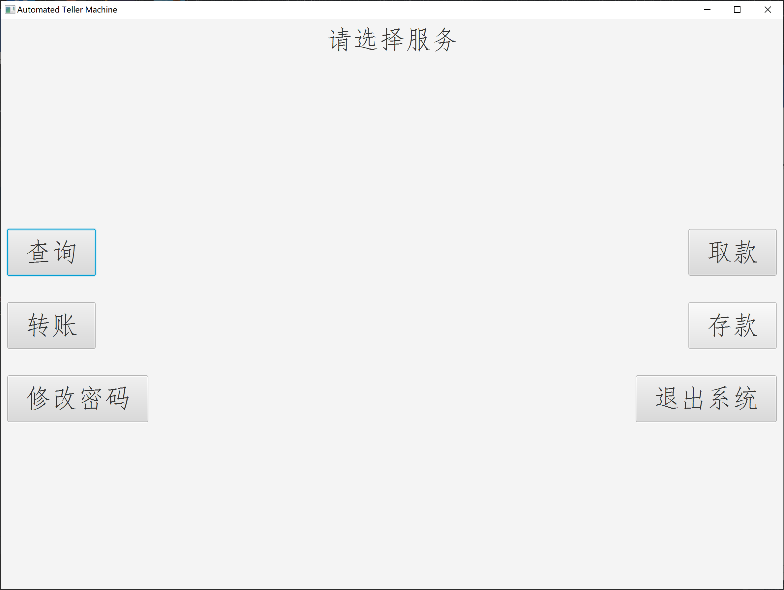

⑥ 存10000元到本账户中
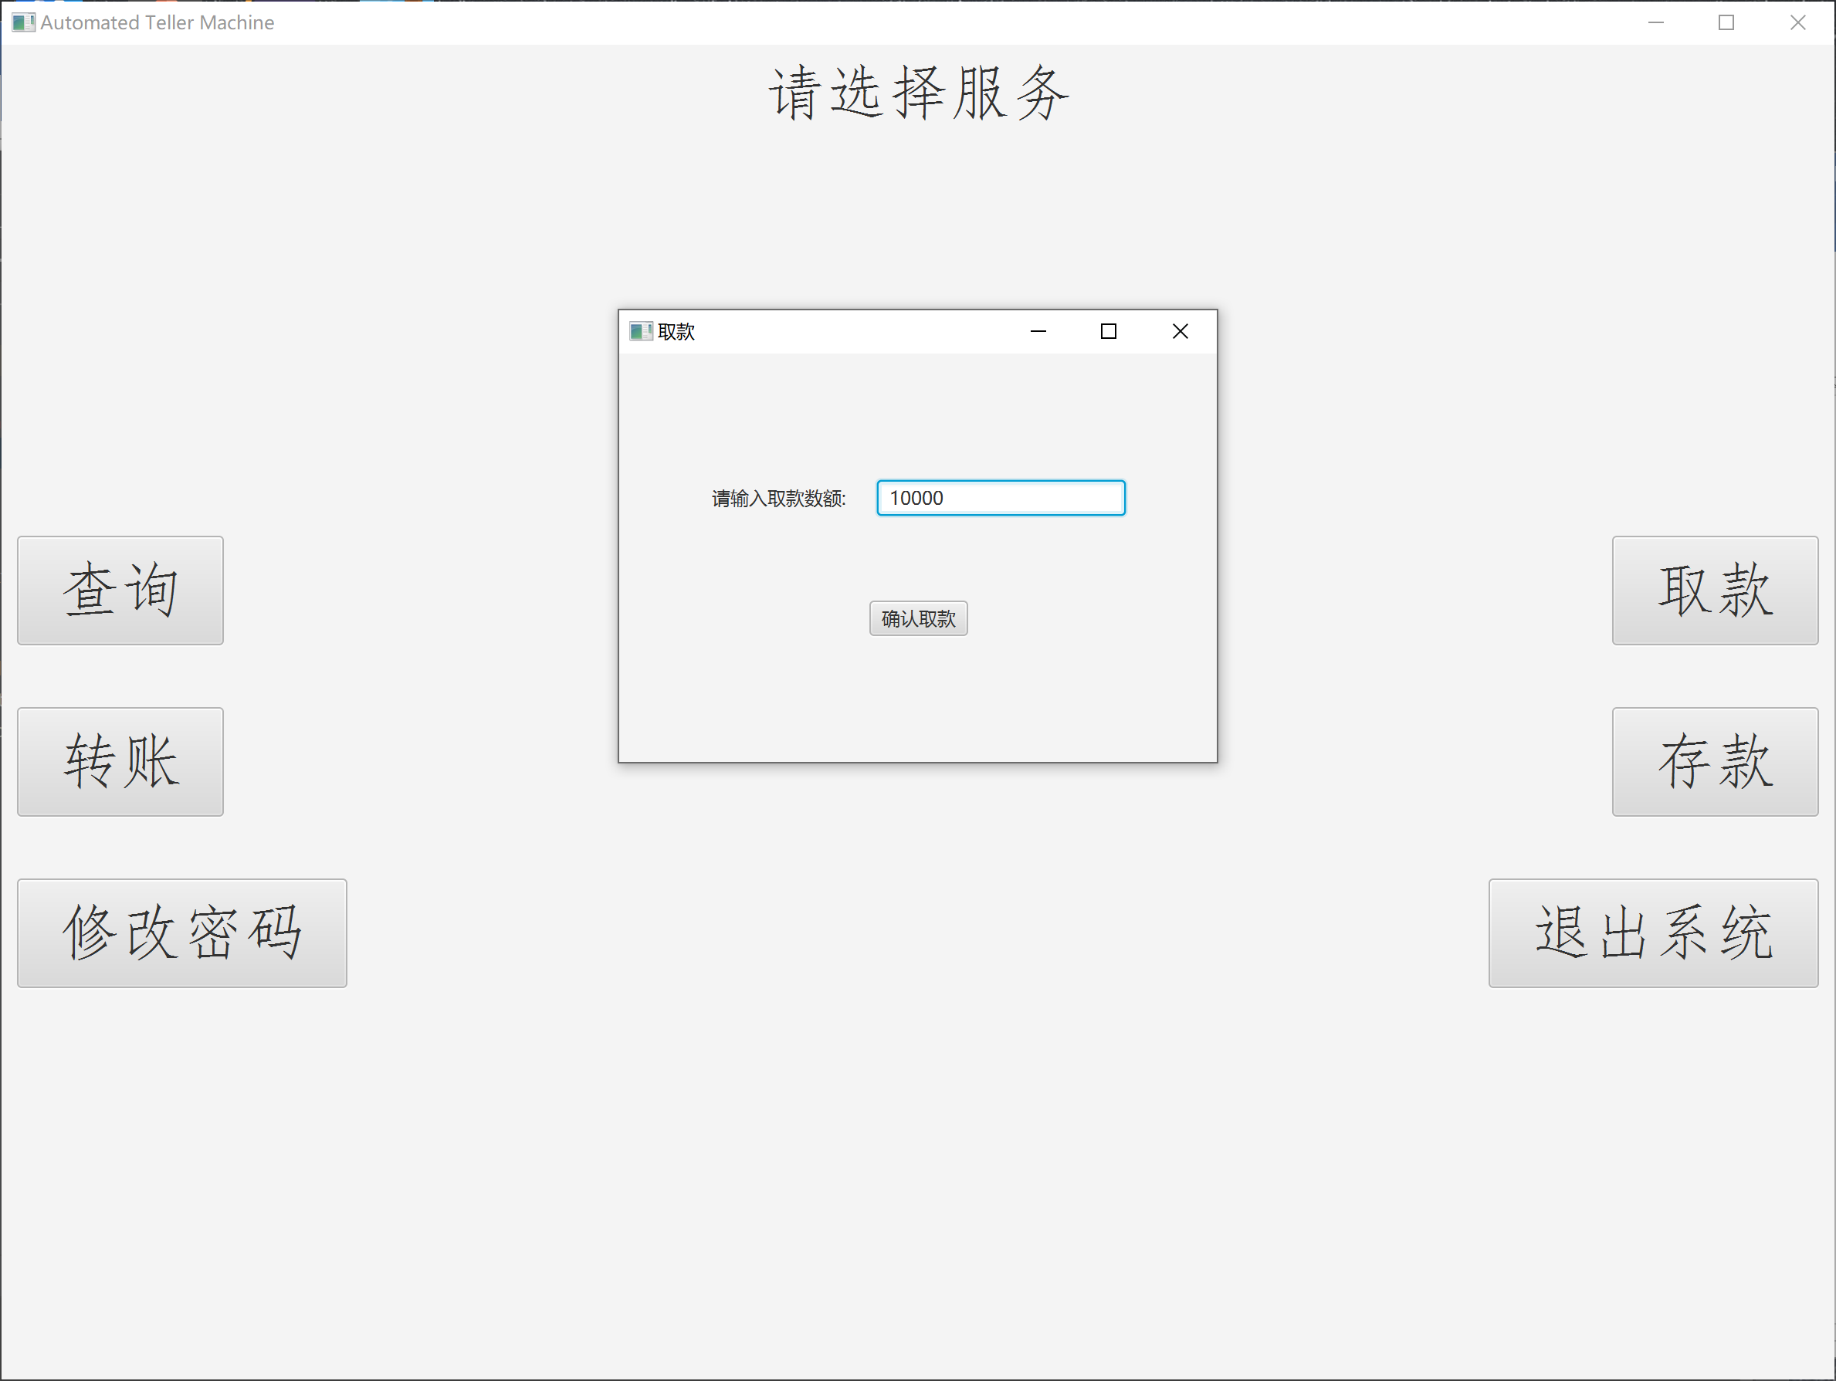
⑦ 查询余额，查看钱数。
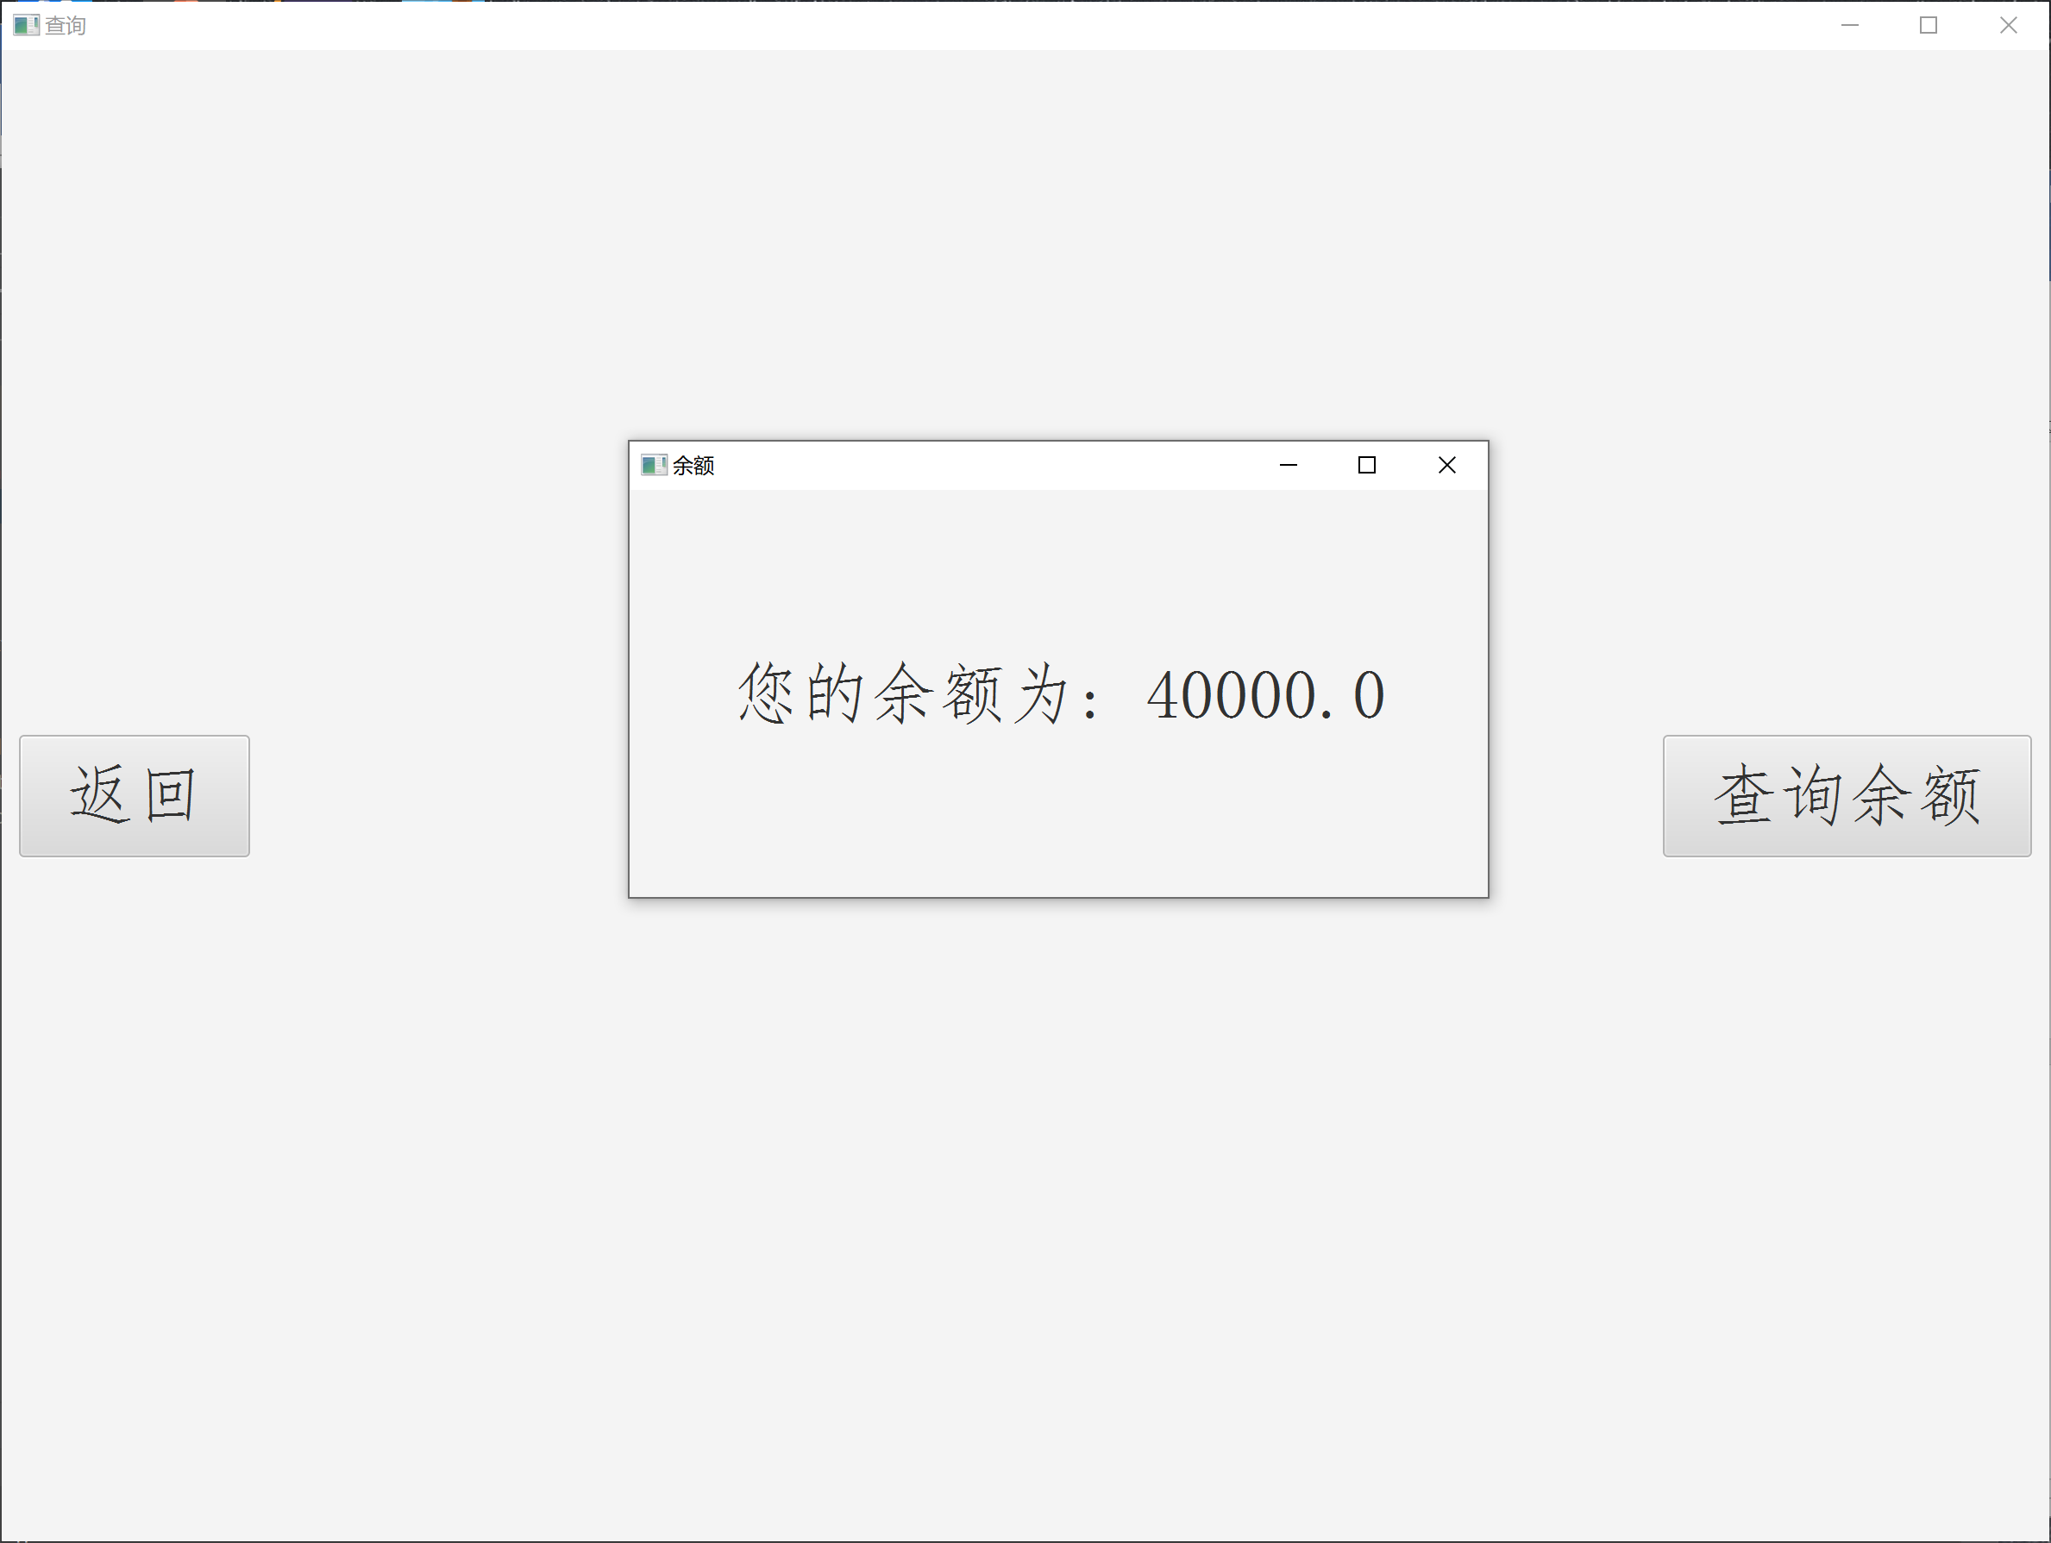

⑧ 点击取款，进行操作。
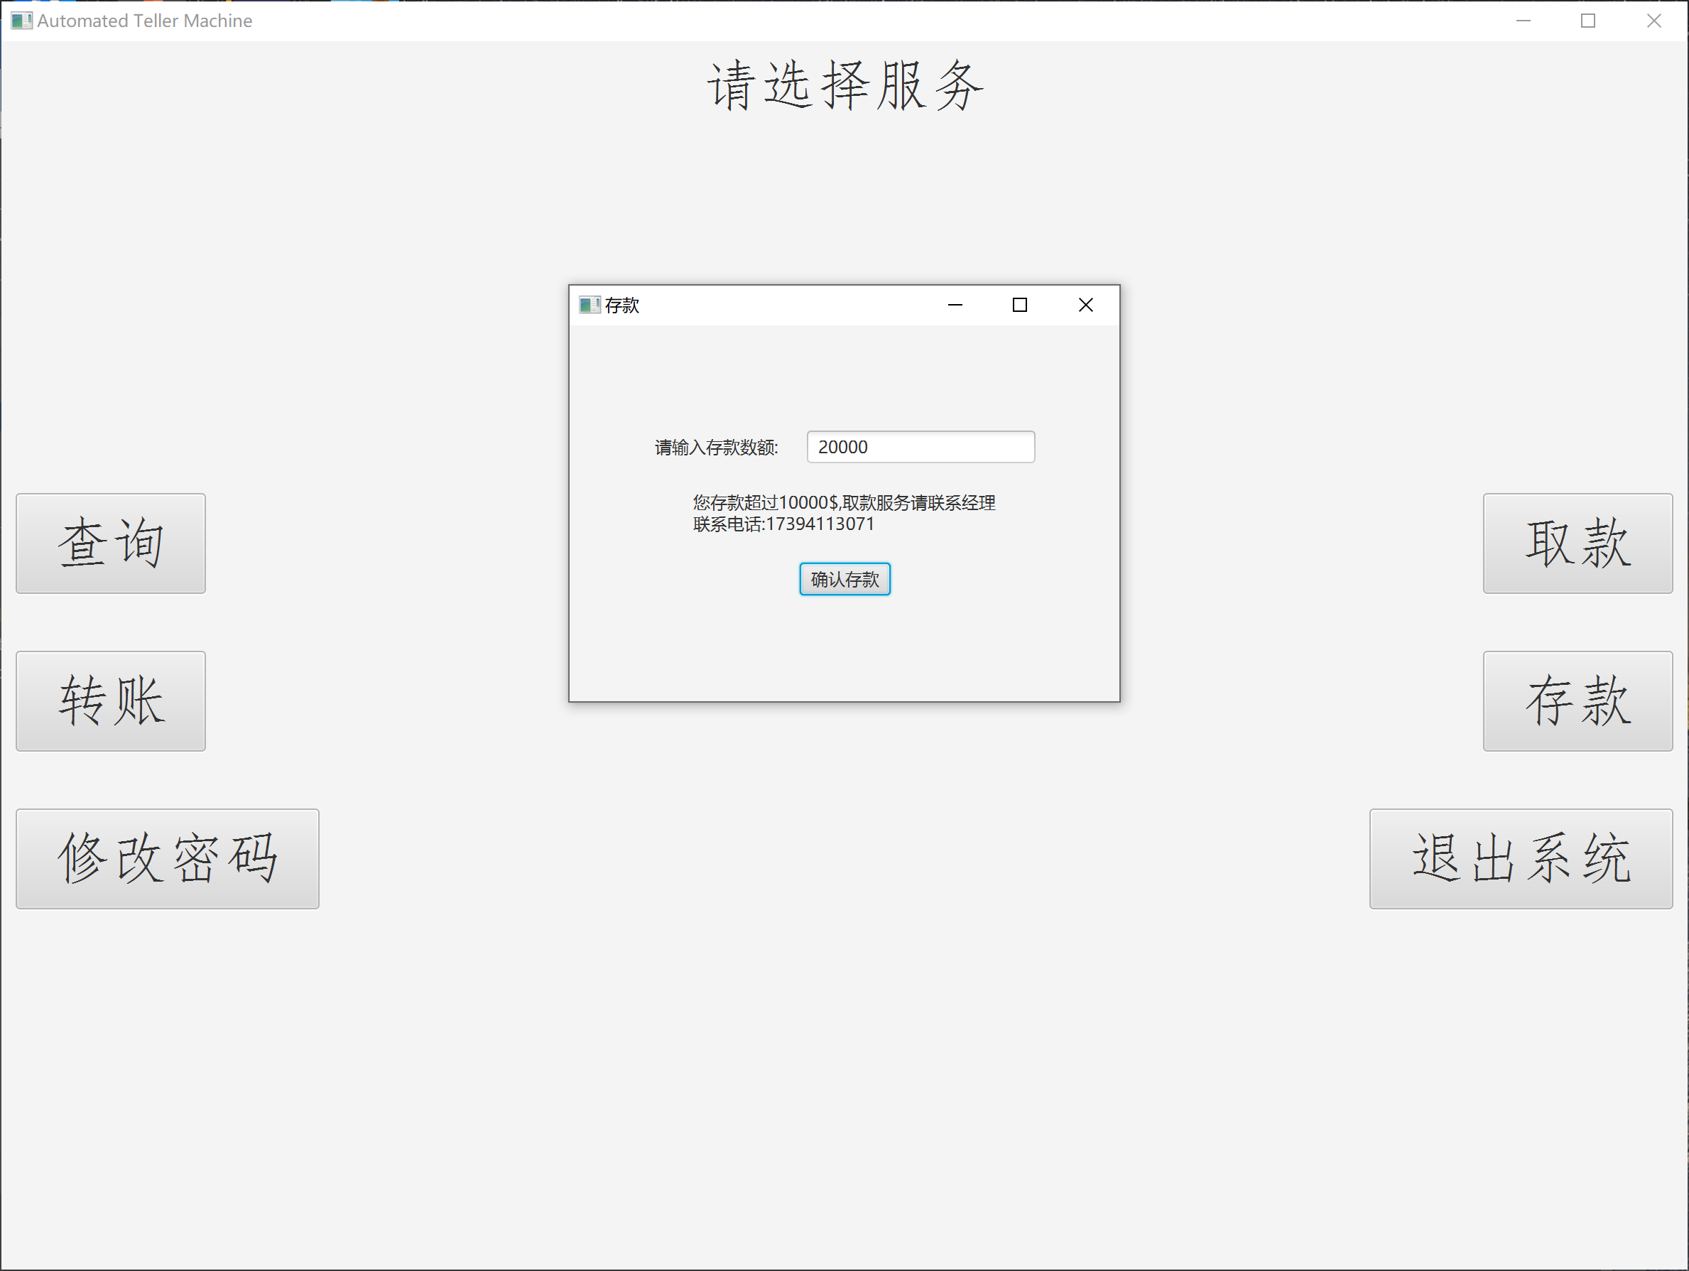

⑨ 点击修改密码，进行密码的修改操作。
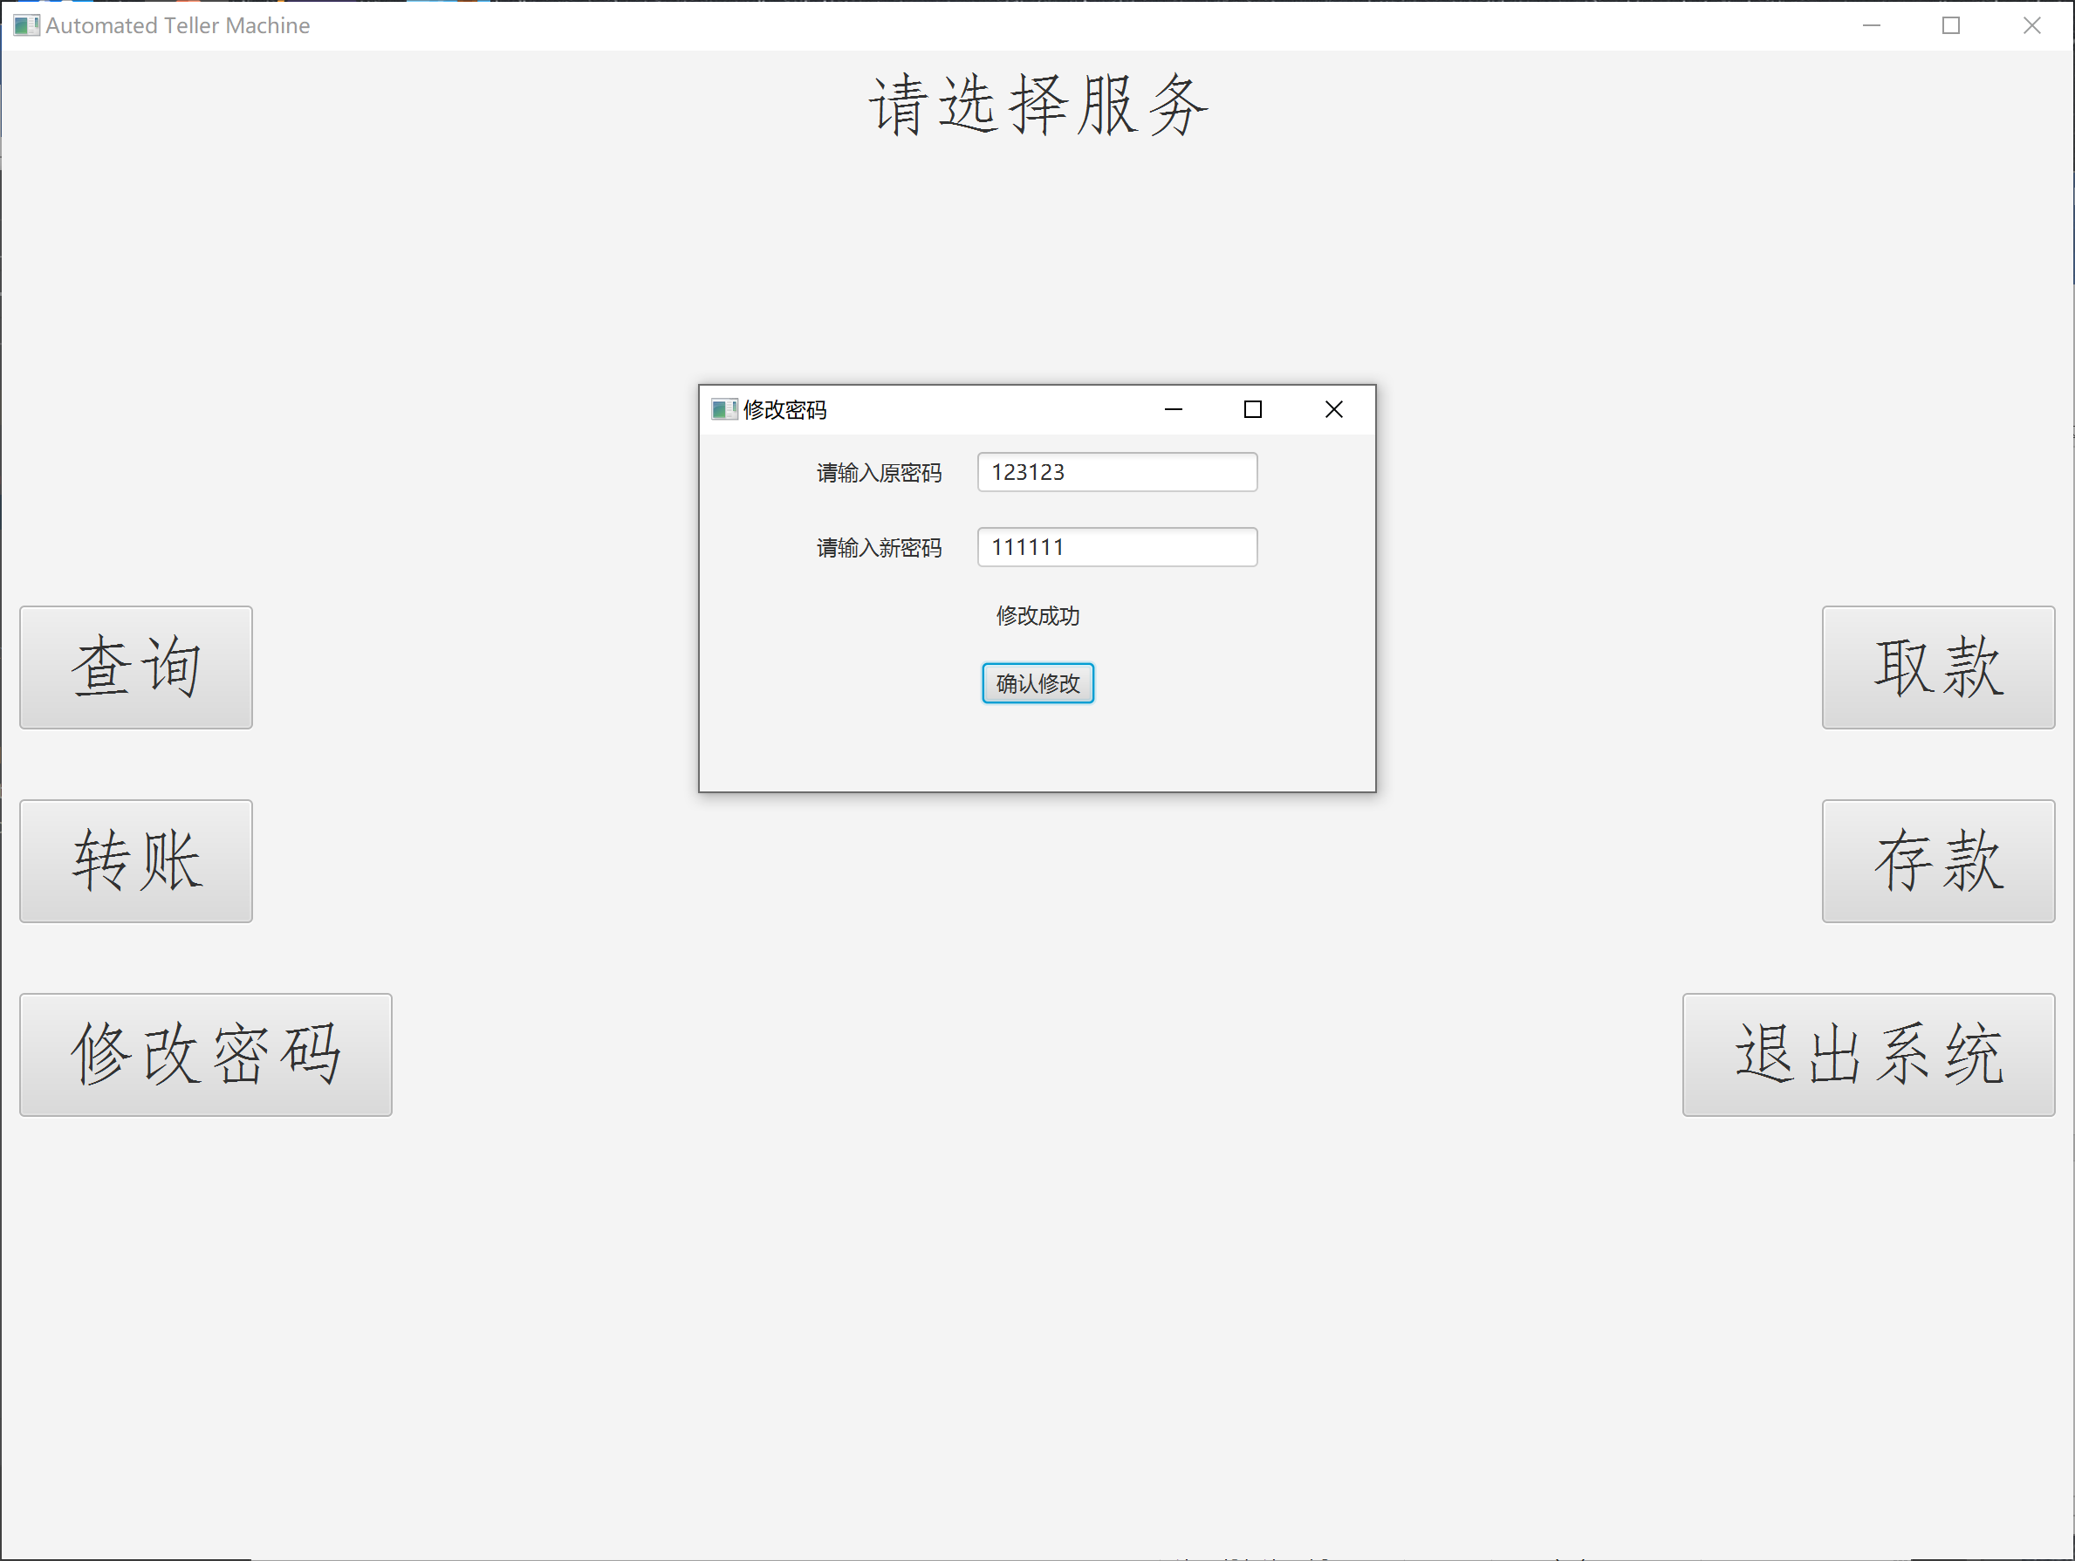

⑩ 点击转账服务，可以向银行其他用户转账
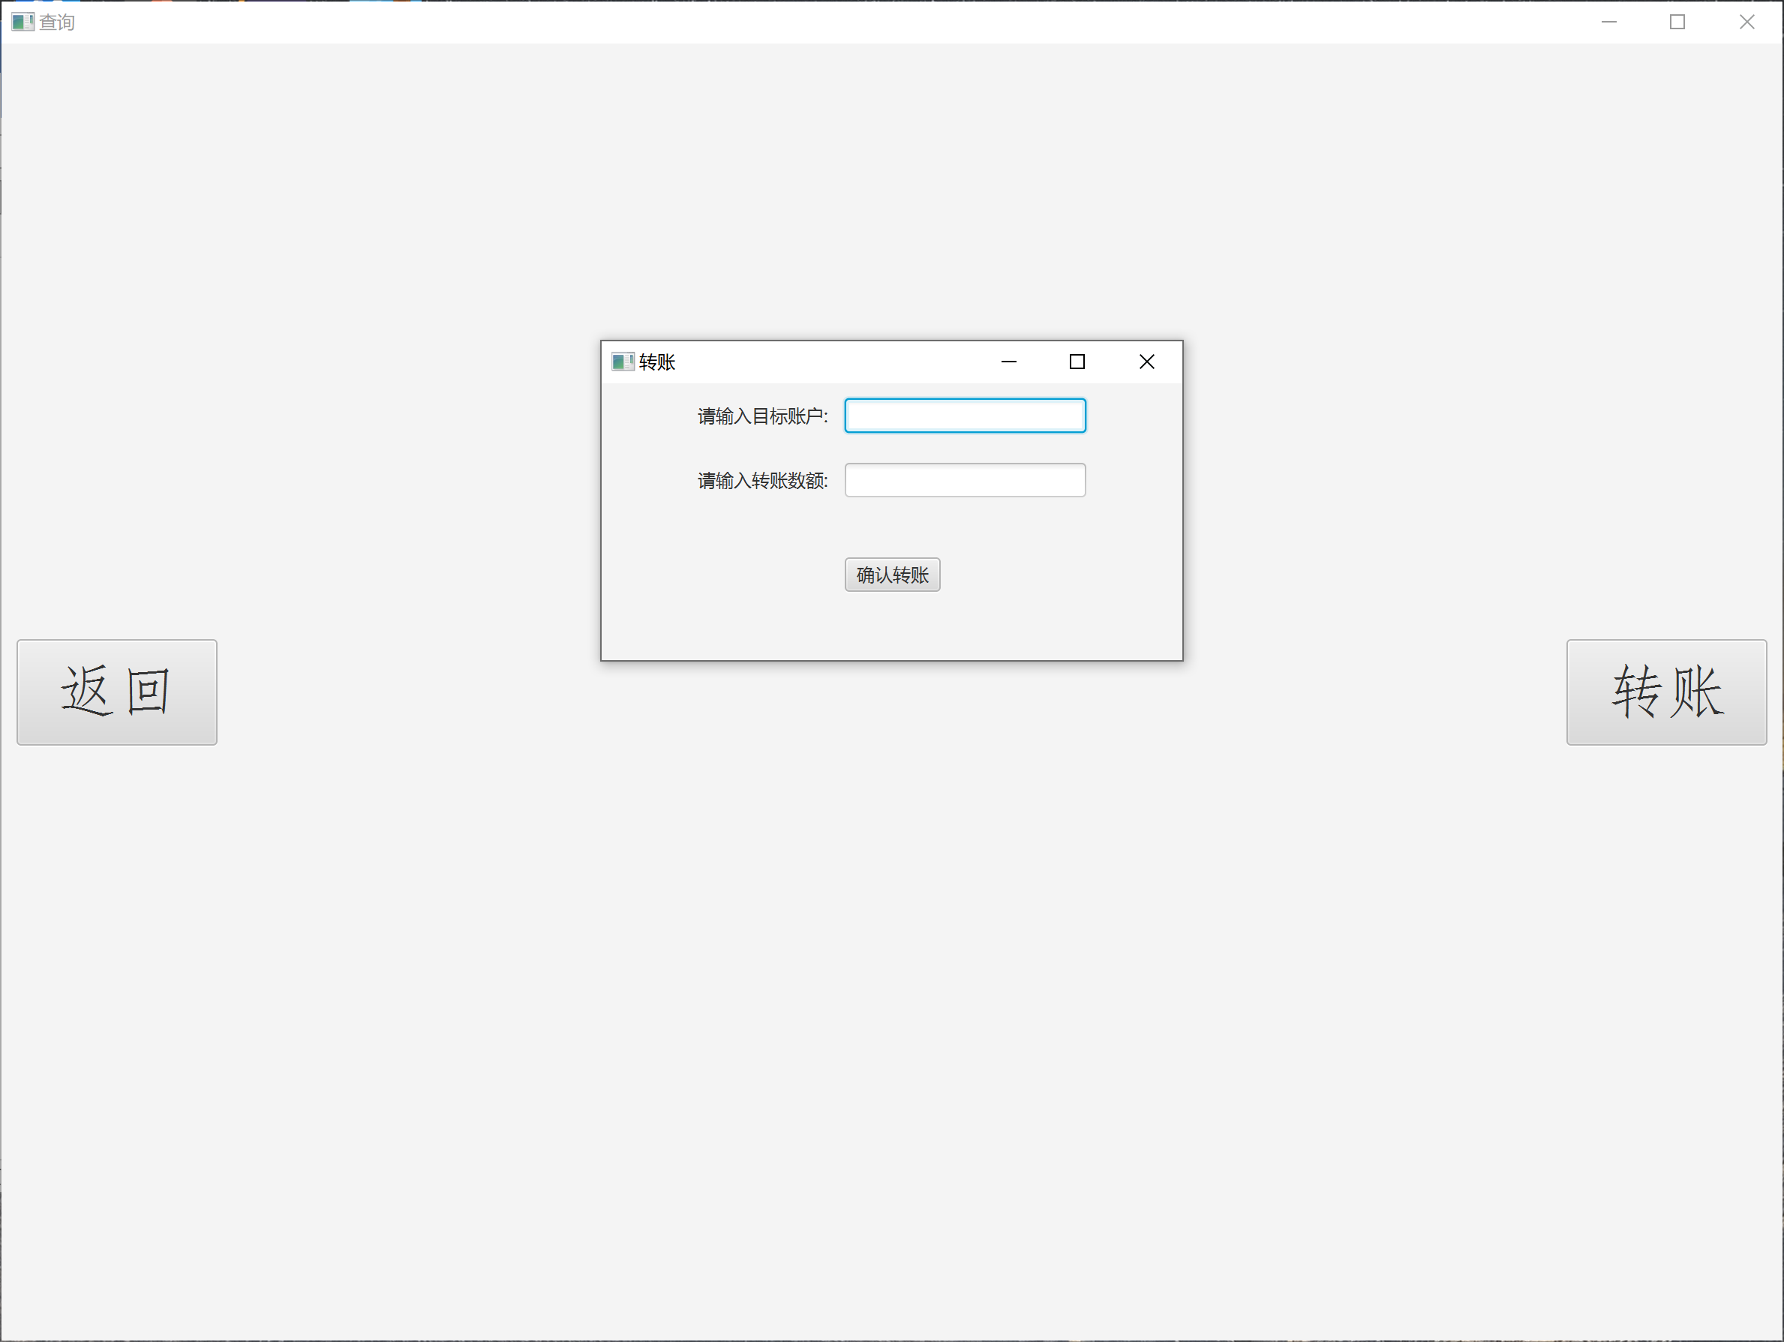
（5）自我评价
功能：
① 进行账户的创建操作。
② 进行本账户的查询余额、转账、修改密码、取款、存款等操作。
③ 可以在用户文件中查询到所有用户的账户具体信息。

界面：
① 登录界面分为已有用户登录和新用户创建。
② 进入服务页面后，左右两侧包含有完整的服务选项，方便用户操作。
③ 新用户注册页面，由系统随机生成账号；由用户自己设定密码。操作简洁。

稳定性：
① 程序稳定性好、鲁棒性强。

